PYTHHON PROGRAMMING

Lab-28 Answers

HAREESHA H M

AF0364330

1. Write a Pandas program to split the following data frame into groups based on Class and count the number of students in that particular class.Also generate a bar chart based on the result and explain the conclusion. Input:

[student_data](https://aln.anudip.org/mod/resource/view.php?id=20372) = pd.DataFrame({ 'school_code': ['s001','s002','s003','s001','s002','s004'], 'class': ['V', 'VI', 'VI', 'VI', 'V', 'VI'], 'name': ['Alberto Franco','Gino Mcneill','Ryan Parkes', 'Eesha Hinton', 'Gino Mcneill', 'David Parkes'], 'age': [12, 12, 13, 13, 14, 12], 'height': [173, 192, 186, 167, 151, 159], 'weight': [35, 32, 33, 30, 31, 32], 'address': ['street1', 'street2', 'street3', 'street1', 'street2', 'street4']},

Code:

import pandas as pd #importing pandas as pd.

import matplotlib.pyplot as plt #importing matplotlib as plt.

# Creating the DataFrame

student_data = pd.DataFrame({

    'school_code': ['s001', 's002', 's003', 's001', 's002', 's004'],

    'class': ['V', 'VI', 'VI', 'VI', 'V', 'VI'],

    'name': ['Alberto Franco', 'Gino Mcneill', 'Ryan Parkes', 'Eesha Hinton', 'Gino Mcneill', 'David Parkes'],

    'age': [12, 12, 13, 13, 14, 12],

    'height': [173, 192, 186, 167, 151, 159],

    'weight': [35, 32, 33, 30, 31, 32],

    'address': ['street1', 'street2', 'street3', 'street1', 'street2', 'street4']

})

class_counts = student_data.groupby('class').size()# Grouping by 'class' and counting the number of students in each class.

class_counts.plot(kind='bar', color='skyblue')# Generating a bar chart.

plt.title('Number of Students in Each Class') #giving the title of the project.

plt.xlabel('Class')

plt.ylabel('Number of Students')

plt.xticks(rotation=0)

plt.show()

Output:

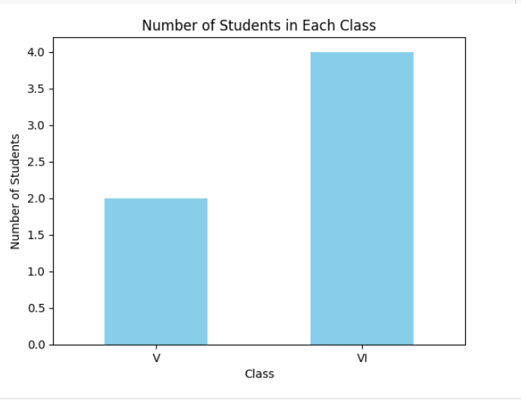

2.  Write a Pandas program to split the following dataframe by school code and get mean, min, and max value of age for each school. Also generate a horizontal bar chart based on the result and explain the conclusion. Input:

[student_data](https://aln.anudip.org/mod/resource/view.php?id=20372) = pd.DataFrame({ 'school_code': ['s001','s002','s003','s001','s002','s004'], 'class': ['V', 'V', 'VI', 'VI', 'V', 'VI'], 'name': ['Alberto Franco','Gino Mcneill','Ryan Parkes', 'Eesha Hinton', 'Gino Mcneill', 'David Parkes'], 'age': [12, 12, 13, 13, 14, 12], 'height': [173, 192, 186, 167, 151, 159], 'weight': [35, 32, 33, 30, 31, 32], 'address': ['street1', 'street2', 'street3', 'street1', 'street2', 'street4']}, )

Code:

import pandas as pd #importing pandas as pd.

import matplotlib.pyplot as plt#importing matplotlib as plt.

# Creating the DataFrame

student_data = pd.DataFrame({

    'school_code': ['s001', 's002', 's003', 's001', 's002', 's004'],

    'class': ['V', 'V', 'VI', 'VI', 'V', 'VI'],

    'name': ['Alberto Franco', 'Gino Mcneill', 'Ryan Parkes', 'Eesha Hinton', 'Gino Mcneill', 'David Parkes'],

    'age': [12, 12, 13, 13, 14, 12],

    'height': [173, 192, 186, 167, 151, 159],

    'weight': [35, 32, 33, 30, 31, 32],

    'address': ['street1', 'street2', 'street3', 'street1', 'street2', 'street4']

})

school_age_stats = student_data.groupby('school_code')['age'].agg(['mean', 'min', 'max'])# Grouping by 'school_code' and calculating mean, min, and max age for each school.

school_age_stats.plot(kind='barh', color=['lightblue', 'skyblue', 'dodgerblue'])# Generating a horizontal bar chart.

plt.title('Age Statistics by School') #Giving the title for chart.

plt.xlabel('Age')

plt.ylabel('School Code')

plt.show()

Output:

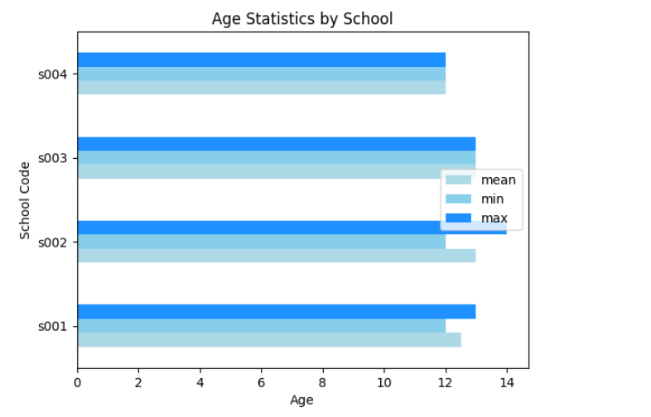

3.  Write a Pandas program to split a dataset, group by one column and get mean, min, and max values by group. Using the following dataset find the mean, min, and max values of purchase amount (purch_amt) group by customer id (customer_id).Also generate a line chart based on the result and explain the conclusion. Input:

orders_data = pd.DataFrame({ 'ord_no':[70001,70009,70002,70004,70007,70005,70008,70010,70003,70012,70011, 70013], 'purch_amt':[150.5,270.65,65.26,110.5,948.5,2400.6,5760,1983.43,2480.4,250.45, 75.29,3045.6], 'ord_date': ['2012-10-05','2012-09-10','2012-10-05','2012-08-17','2012-09-10','2012-07-27','2012- 09-10','2012-10-10','2012-10-10','2012-06-27','2012-08-17','2012-04-25'], 'customer_id':[3005,3001,3002,3009,3005,3007,3002,3004,3009,3008,3003,3002], 'salesman_id': [5002,5005,5001,5003,5002,5001,5001,5006,5003,5002,5007,5001]})

Code:

import pandas as pd #importing pandas as pd.

import matplotlib.pyplot as plt #importing matplotlib as plt.

# Creating the DataFrame.

orders_data = pd.DataFrame({

    'ord_no':[70001, 70009, 70002, 70004, 70007, 70005, 70008, 70010, 70003, 70012, 70011, 70013],

    'purch_amt':[150.5, 270.65, 65.26, 110.5, 948.5, 2400.6, 5760, 1983.43, 2480.4, 250.45, 75.29, 3045.6],

    'ord_date': ['2012-10-05', '2012-09-10', '2012-10-05', '2012-08-17', '2012-09-10', '2012-07-27', '2012-09-10',

                 '2012-10-10', '2012-10-10', '2012-06-27', '2012-08-17', '2012-04-25'],

    'customer_id':[3005, 3001, 3002, 3009, 3005, 3007, 3002, 3004, 3009, 3008, 3003, 3002],

    'salesman_id': [5002, 5005, 5001, 5003, 5002, 5001, 5001, 5006, 5003, 5002, 5007, 5001]

})

customer_purchase_stats = orders_data.groupby('customer_id')['purch_amt'].agg(['mean', 'min', 'max'])# Grouping by 'customer_id' and calculating mean, min, and max purchase amount for each customer.

customer_purchase_stats.plot(kind='line', marker='o')# Generating a line chart.

plt.title('Purchase Amount Statistics by Customer')

plt.xlabel('Customer ID')

plt.ylabel('Purchase Amount')

plt.grid(True)

plt.show()

Output:

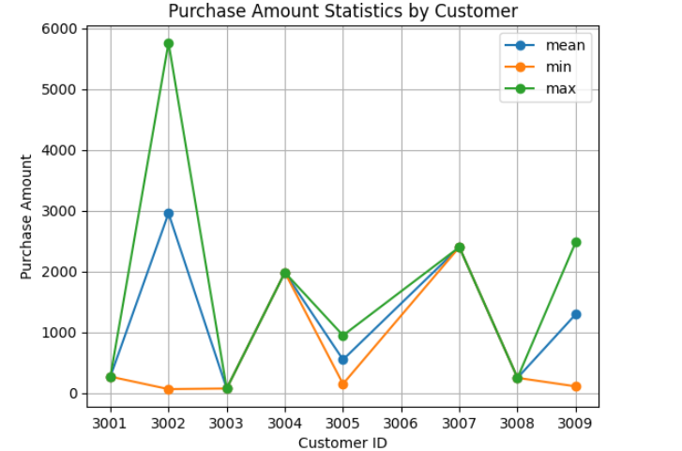

4. Write a Pandas program to split the following data frame into groups and calculate monthly purchase amount.Also generate a bar chart based on the result and explain the conclusion. Input:

 df = pd.DataFrame({ 'ord_no':[70001,70009,70002,70004,70007,70005,70008,70010,70003,70012,70011, 70013], 'purch_amt':[150.5,270.65,65.26,110.5,948.5,2400.6,5760,1983.43,2480.4,250.45, 75.29,3045.6], 'ord_date': ['05-10-2012','09-10-2012','05-10-2012','08-17-2012','10-09-2012','07-27-2012','10-09- 2012','10-10-2012','10-10-2012','06-17-2012','07-08-2012','04-25-2012'], 'customer_id':[3001,3001,3005,3001,3005,3001,3005,3001,3005,3001,3005,3005],

Code:

import pandas as pd #importing pandas as pd.

import matplotlib.pyplot as plt #importing matplotlib as plt.

# Creating the DataFrame.

df = pd.DataFrame({

    'ord_no': [70001, 70009, 70002, 70004, 70007, 70005, 70008, 70010, 70003, 70012, 70011, 70013],

    'purch_amt': [150.5, 270.65, 65.26, 110.5, 948.5, 2400.6, 5760, 1983.43, 2480.4, 250.45, 75.29, 3045.6],

    'ord_date': ['05-10-2012', '09-10-2012', '05-10-2012', '08-17-2012', '10-09-2012', '07-27-2012', '10-09-2012',

                 '10-10-2012', '10-10-2012', '06-17-2012', '07-08-2012', '04-25-2012'],

    'customer_id': [3001, 3001, 3005, 3001, 3005, 3001, 3005, 3001, 3005, 3001, 3005, 3005]

})

df['ord_date'] = pd.to_datetime(df['ord_date'], format='%m-%d-%Y')# Convert 'ord_date' to datetime format.

df['month'] = df['ord_date'].dt.month # Extract month from 'ord_date'.

monthly_purchase = df.groupby('month')['purch_amt'].sum()# Grouping by 'month' and calculating monthly purchase amount.

monthly_purchase.plot(kind='bar', color='skyblue')# Generating a bar chart.

plt.title('Monthly Purchase Amount') # Giving the title for chart.

plt.xlabel('Month')

plt.ylabel('Total Purchase Amount')

plt.xticks(rotation=0)

plt.show()

Output:

